K8s pod.yaml file ;
We need to create a pod.yaml file to define the pod configuration.

1. Create the pod.yaml File
vim pod.yaml
Add the following YAML configuration to the file:
apiVersion: v1
kind: Pod
metadata:
name: ems-pod
labels:
app: ems
spec:
containers:
- name: ui-container
image: yatheesh836/ems:ui-i
ports:
- containerPort: 3000
resources:
limits:
memory: "1Gi"
cpu: "1000m"
requests:
memory: "512Mi"
cpu: "500m"
- name: identity-container
image: yatheesh836/ems:identity-i
ports:
- containerPort: 3001
resources:
limits:
memory: "512Mi"
cpu: "500m"
requests:
memory: "256Mi"
cpu: "250m"
- name: employee-container
image: yatheesh836/ems:e-i
ports:
- containerPort: 3002
resources:
limits:
memory: "512Mi"
cpu: "500m"
requests:
memory: "256Mi"
cpu: "250m"

Explanation of pod.yaml File:
- apiVersion: Specifies the version of the Kubernetes API you're using (v1 for basic pod functionality).
- kind: Specifies that this resource is a Pod.
- metadata: Contains the name of the pod and optional labels, which can help with grouping resources.
- spec: Defines the spec for the Pod, including the containers it should run.
  - containers: Lists the containers to run inside the pod:
    - name: Name of the container.
    - image: The Docker image for the container.
    - ports: The container ports to expose (e.g., 3000, 3001, 3002).
    - resources: Defines CPU and memory limits and requests for each container.

Usage
- Save the above YAML content to a file named pod.yaml.
- To create the pod, run the following command:
kubectl apply -f pod.yaml
This will deploy a pod with three containers running within it. Each container will be accessible on the ports you specified (3000, 3001, and 3002) but only within the Pod itself.
If you want to expose these services externally or across other Pods, you would typically use a Kubernetes Service resource, but this is not necessary if you are just running containers inside the same pod.

Checking Pods
To see how many pods are running:
kubectl get pods
To delete a pod:
kubectl delete pod ems-pod

Creating and Displaying Pods
Once you've created the pod, you can list the running pods with:
kubectl get pods

Exposing a Pod
To expose the application and make it accessible externally, use the following command:

kubectl expose pod ems-pod --port=5000 --name=ems-ui-service --type=NodePort
In this case, the UI is running on port 3000 inside the pod, but you've exposed it on port 5000. Now you can access it via the NodePort.

Deleting a Service
To delete the service, run:
kubectl delete svc ems-ui-service
Now, to expose the pod again but with the correct internal port (3000), use:
kubectl expose pod ems-pod --port=3000 --name=ems-ui-service --type=NodePort

Checking Which Port is Exposed
To check which port is assigned to the service, run:
kubectl get svc ems-ui-service
The output will show you the port number assigned by Kubernetes. Even though your pod is running on port 3000, Kubernetes may assign a different external port (e.g., 30188).

Checking the Port Inside the Pod
To check the ports being used inside the pod, you can run:
kubectl exec -it ems-pod -- netstat -tuln
This will show the active ports inside the pod, confirming that port 3000 is being used.

My documentation ;
We need to create one pod.yaml file,
Vim pod.yaml
Add to the down side file,
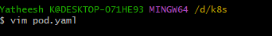

apiVersion: v1
kind: Pod
metadata:
name: ems-pod
labels:
app: ems
spec:
containers:
- name: ui-container
image: yatheesh836/ems:ui-i
ports:
- containerPort: 3000
resources:
limits:
memory: "1Gi"
cpu: "1000m"
requests:
memory: "512Mi"
cpu: "500m"
- name: identity-container
image: yatheesh836/ems:identity-i
ports:
- containerPort: 3001
resources:
limits:
memory: "512Mi"
cpu: "500m"
requests:
memory: "256Mi"
cpu: "250m"
- name: employee-container
image: yatheesh836/ems:e-i
ports:
- containerPort: 3002
resources:
limits:
memory: "512Mi"
cpu: "500m"
requests:
memory: "256Mi"
cpu: "250m"

Explanation: pod.yaml file
- apiVersion: Specifies the version of the Kubernetes API you're using (v1 for basic pod functionality).
- kind: Specifies that this resource is a Pod.
- metadata: Contains the name of the pod and an optional label. The label can help in selecting and grouping resources.
- spec: Defines the spec for the Pod, including the containers it should run.
  - containers: Lists the containers to run inside the pod:
    - name: Name of the container.
    - image: The Docker image for the container.
    - ports: The container ports to expose (5000, 5001, 5002) inside the pod.

Usage
To apply this configuration:
- Save the above YAML content to a file named pod.yaml.
- Run the following command to create the pod
kubectl apply -f pod.yaml
This will deploy a pod with three containers running within it. Each container will be accessible on the ports you specified (5000, 5001, and 5002) but only within the Pod itself.
If you want to expose these services externally or across other Pods, you would typically use a Kubernetes Service resource, but that is not required if you're just running these containers within the same pod.

How to apply the pods.yaml file
To create a pod using the above configuration, you can run the following command:
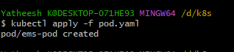
How many pods running,
Kubectl get pods
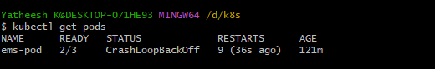
Delete pods,
Kubectl delete pod ems-pod
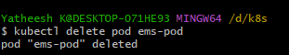
Check pods,
Kubuctl get pods
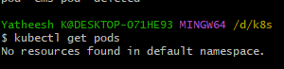
How to create pods and command, [Create pods]

created pods pods displaying to the like this down side,
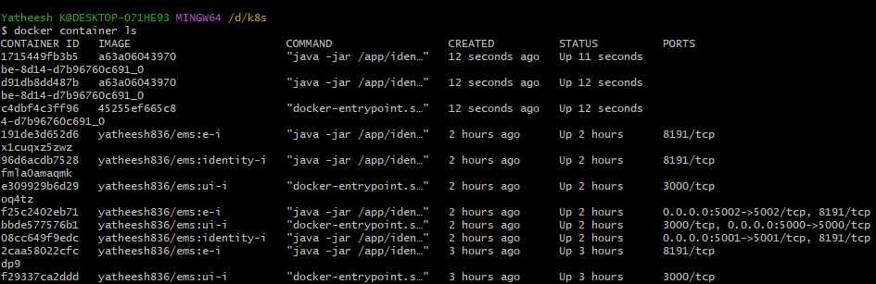

Expose
Expose means we need to see our application before we see run this command,
Kubuctl expose pod ems-pod –port=5000 –name=ems-ui-service –type=nodeport

Actualu my ui run on 3000 port number, heare I create the 5000 port number, now I need to remove to the this port number,
Remove or delete service,
Kubuctl delete svc ems-ui-service
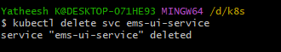

Now I create this pod port number is 3000 [service createing]
Kubuctl expose pod ems-pod –port=3000 –name=ems-ui-service –type=nodeport

Which port number runnimg on our modiles check like this,
Kubectl exce -it ems-pod –netstat -tuln
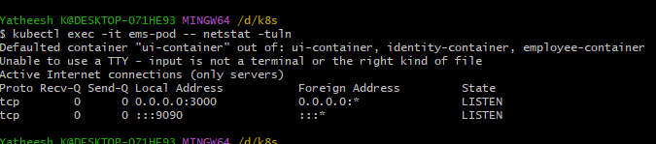

Kubectl get svc ems-ui-service output check this port number 30188 [my port number is 3000, but system was give this port number 30188]
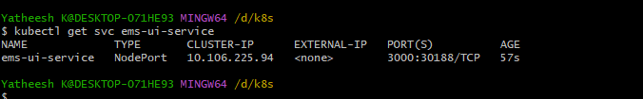

This is ui output

